**Changing port:**

* Go to conf/server.xml file
* Search for existing port number (/8080) and change it. Then restart tomcat

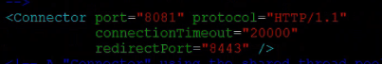

**Changing the App Base:**

* We can change the app base in “**conf/server.xml**”. then restart the tomcat
* App base is nothing but the location of our applications, write now it is webapps folder



* Now, we can’t access the tomcat, as we don’t have anything in new app base location
* We can copy any war file and access it. Then access it with Localhost: port/leadapp/

**Auto Deploy Feature:**

* We can find the below entry in **conf/server.xml** file. If the autodeploy is set to true. When we do the deployment, the application will be automatically loaded.
* If we set it to false, we need to restart tomcat after the deployment.

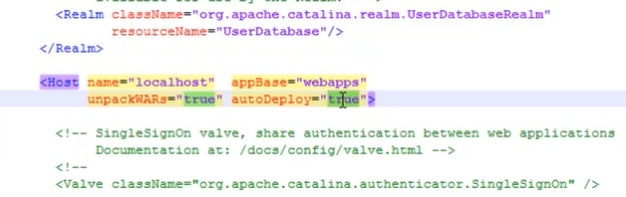

**Clean restart:**

* If we want to perform clean restart of tomcat, shutdown the tomcat, then we need to clear the files inside tmp, logs and work/Catalina/localhost which contains cache of tomcat and then start it
* After this it will create new cache
* Sometimes, developer may ask even after the changes, it is not reflecting on deployment. So, we may need to do it

**Checking the server status from console:**

* We can see the server status option on the homepage of console. With that, we can get the basic details of tomcat server as below.

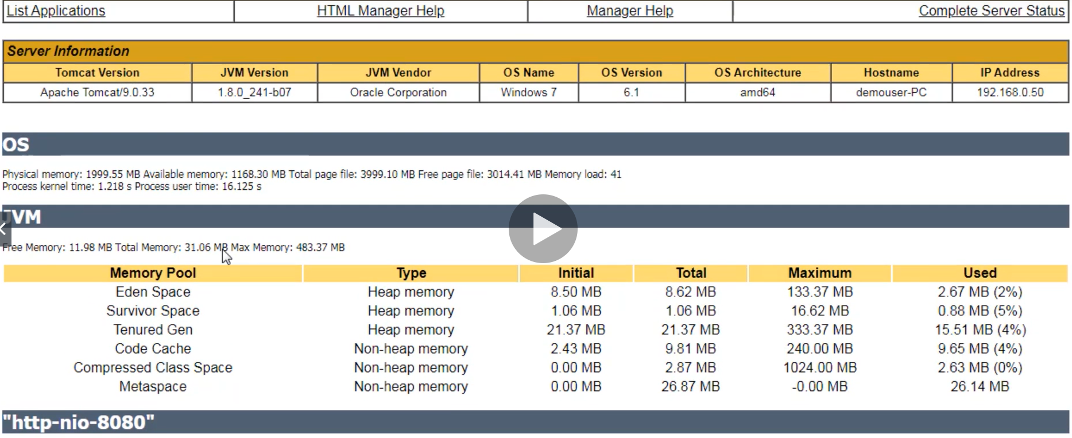

* These things will be helpful when we do performance related tasks.